Section 4(ii) & (iii) | Team Structure, Experience and Qualification of the Team
6.0 | Property Management Services Provider



Company Profile

China Overseas Property Services Limited has a heritage of professional property management services provision for over 39 years for our customers over Hong Kong and Macau. Our business covers ten major categories, including Central Government and Military Bases projects in Hong Kong and Macau, Hong Kong Government public buildings, commercial office buildings, high-end residential properties, high schools, hospitals, cultural heritage sites, etc. We currently employs over 10,000 staff and manages 260 projects, covering an area of over 12 million square meters.

Being uncompromising to Customer Focus and Quality Service, we are committed to working hand-in-hand with the University of Hong Kong to pursue continual value added operation and maintenance services, and student engagement and community programming services.

Our Journey

China Overseas Property Holdings Limited ("COPL") is a subsidiary of China Overseas Holdings Limited under China State Construction Engineering Corporation and an avant-garde in the property management industry in China with first-class qualifications. COPL started its property management services in Hong Kong in 1986, and have gained over 30 years of cultivation in Hong Kong and Macau, COPL set foot in the Mainland China market in 1991. COPL fully integrates the property management experience in Hong Kong into the practical situation in Mainland China. On 23 October 2015, COPL was listed on the Main Board of The Stock Exchange of Hong Kong Limited (Stock Code: 2669.HK), marking its official entry into the global capital market.
Projects

Our extensive portfolio includes, but not limited to:

- The Education University of Hong Kong (2025-2028)
- The Create of the Hang Seng University of Hong Kong (2025-2027)
- Hong Kong Art Centre and Art School Campuses (2025-2028)
- Government Accommodation at Landmark South of Hong Kong Arts Development Council (2025-2027)
- University of Macau (2019-2027)
- Macau University of Science and Technology (2022-2026)
- Hong Kong Palace Museum (2025-2028)
- The Hong Kong Police Headquarters Complexes (2022-2028)
- One Kai Tak (2017-present)
- One Victoria (2022-presemt)
- So Uk Estate and Hoi Tat Estate (2021-2028)
- Po Tin Estate and Fu Tai Estate (2022-2027)
- Kai Tak Cruise Terminal (2013-2027)

Our Expertise

As the largest property services provider across Hong Kong and Macau, we operate through eight specialized subsidiaries to deliver an unparalleled benchmark of real estate excellence. According to independent market research by Frost & Sullivan, our organization has firmly held the market-leading position in the Hong Kong Property Management Sector for three consecutive years (2022–2024).

Our proven track record is built upon delivering prestigious, institutional-grade property management services across an expansive portfolio of large-scale, high-profile, and strategically critical assets. Assured by our elite clients, our end-to-end operational capabilities span every aspect of premium property management: management services, security services, landscaping services, cleaning and pest control services, maintenance and repair services, takeover of properties, financial management, emergency handling, project consultancy services, etc.

Our Vision

At China Overseas Property Services, we live by our core value: “To Forge Ahead with All One's Heart Every Day.” We are deeply committed to delivering high-quality, attentive property management services that strictly safeguard our clients’ rights and exceed their institutional expectations.

In enduring partnership with the University of Hong Kong and Po Leung Kuk, our vision is to establish the Student Hostel as the premier gold standard for university housing in Hong Kong. Driven by our market-leading expertise and a profound sense of institutional honor, we combine world-class property management with an enriching, supportive residential ecosystem. We are dedicated to delivering an uncompromised environment of absolute safety, financial resilience, and operational excellence that safeguards HKU’s capital assets while nurturing global talent. To seamlessly bridge infrastructure reliability with student well-being, our service delivery is guided entirely by our core strategic anchor: “More than just accommodation, we are partners in students' growth.”

  - Relevant Project Reference

1.2.1 Similar Projects

Project: | The Education University of Hong Kong


COPSL deployed over 110 staff to cover the entire university, including the main Tai Po campus (approx. 12.5 hectares, including Student Hostels) and satellite centres in EdUHK Sports Centre, Tseung Kwan O Study Centre and North Point Study Centre.

A multi-layered security regime is in place. This includes a 24-hour Security Control Centre, which oversees daily supervision of security teams, contract performance monitoring, key control and enforcement of campus regulations. It also manages security systems such as CCTV, car-parking and transportation automation. Access control is strictly enforced, requiring staff and students to present their University ID, with visitors and contractors required to register at designated counters.

Annual Contract Sum: | HK$33.4M
Contract Period: | 2025-2028
Client: | The Education University of Hong Kong

Project: | Postgraduate and faculty dormitories at the University of Macau (including the W32 Doctoral Building)
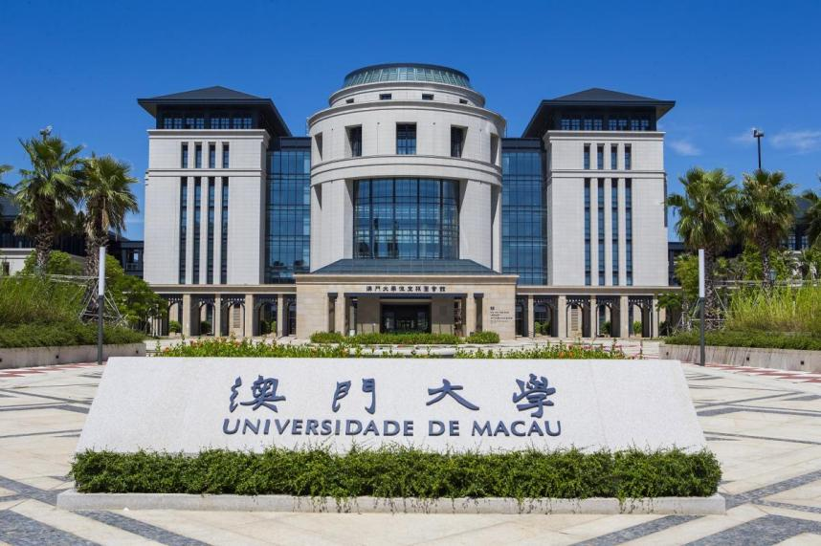

Since first securing the contract in 2019, COPSL has successfully renewed its agreement, commencing its third consecutive term. The latest official tender for comprehensive campus facility maintenance and management services covers the period from January 1, 2026, to June 30, 2027. During its six years of service, the project team has handled move-in and move-out procedures for nearly 20,000 students and cleaned over 7,000 dormitory rooms, consistently receiving high praise from both the university and residents.
The main campus PGH is managed by the Student Resources Section, Student Affairs Office, and currently includes six residential blocks: S1, S2, S3, S4, W31, and W32. All rooms are fully furnished, equipped with air conditioning, and provide shared study rooms, fitness rooms, pantry areas, and laundry/drying rooms.

The W32 Doctoral Building is a notable residential tower, frequently referred to as the "Doctoral Building." It features two-person rooms sharing a bathroom, with most residents being PhD students. The building is equipped with four high-speed elevators per floor, two pantry areas, two drying rooms, and storage rooms. The ground floor (G/F) includes a central cooking area, study rooms, a piano room, a billiards room, and the property management office.

The Staff Quarters are located at the southern tip of the campus, comprising 16 residential buildings
Annual Contract Sum: | HK$11.8M
Contract Period: | 2019-2028
Client: | The University of Macau

Project: | One Kai Tak


One Kai Tak is a unique private residential estate located at 2 Muk Ning Street, Kai Tak, Kowloon. The development comprises two phases, totalling 17 blocks with 1,169 residential units, and was completed in 2017. The two clubhouses feature amenities including a swimming pool, dynamic fitness center, children's playground, flight simulator, karaoke room, and banquet hall. A two-storey shopping mall within the estate offers a supermarket, restaurants, and various retail stores to meet daily needs.

Annual Contract Sum: | HK$112.2M
Contract Period: | 2017-present
Client: | Owners Corporation

Project: | One Victoria


One Victoria is a prominent private residential estate located at 21 Shing Fung Road in the Kai Tak area of Kowloon, Hong Kong. Completed in July 2022, the estate comprises five tower blocks, offering a total of 1,059 residential units. The management team is responsible for maintaining the estate's impressive Club Victoria, a dual-clubhouse facility that spans over 90,000 square feet, including landscaped gardens. It features more than 30 amenities across six themed zones. Key facilities include a 50-metre outdoor landscaped swimming pool, a 20-metre indoor heated swimming pool, a children's racing track, a piano recital hall, a large banquet hall, party rooms, and a fitness centre.

Annual Contract Sum: | HK$2.5M
Contract Period: | 2022-present
Client: | China Overseas Property Holdings Limited

Project: | Property Services for Po Tin Estate and Fu Tai Estate



Po Tin Estate is a public rental housing estate located at 99 Ming Kum Road in the northwestern part of Tuen Mun. Originally developed as a interim housing complex, most units have since been converted to standard public rental flats. The estate comprises nine 28‑storey residential blocks, providing a total of approximately 8,736 flats.
Fu Tai Estate is a standard public housing estate located at 9 Tuen Kwai Road, in the northeastern part of Tuen Mun, near Lingnan University. It consists of 11 residential blocks, offering about 5,100 flats with an estimated population of 16,300 residents.
Annual Contract Sum: | HK$61.2M
Contract Period: | 2022-2027
Client: | Housing Authority

Project: | Provision of Management Services for Aberdeen Staff Quarters at 39 Tsung Man Street (2024-2026)
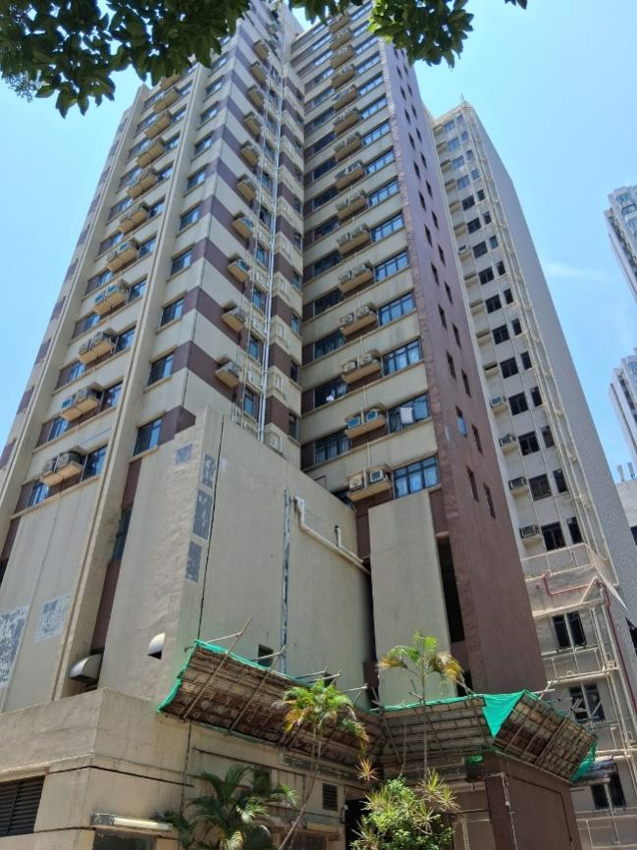

The Hongkong Electric (HK Electric) staff quarters at 39 Tsung Man Street, Aberdeen is a company-owned residential facility serving employees of one of Hong Kong’s two main electricity generation companies.
Annual Contract Sum: | HK$1.14M
Contract Period: | 2024-2026
Client: | HK Electric

  - Duties and Responsibility

The Duties and responsibility of the core personnel are as follow:

Name (Position) | Duties and Responsibility
YUENG Sheung Chun  Senior Property Manager  (Off-site Senior Managerial Staff for monitoring) | Mr. YUEN Sheung Chun will act as off-site Senior Managerial Staff to provide consultancy services and monitor the overall services delivery to the Student Hostel. He will be responsible for the following:  - Act as consultant of the services delivery  - Attend review meeting with HKU regularly  - Monitor the quality of the services delivery  - Provide support during contingent situations
CHAN Man Hin  Head (Youth Affairs)  (Off-site Support Team)  Student Engagement and Community Programming | Mr. CHAN Man Hin will provide off-site professional support to the on-site team. He will be responsible for the following:  - Lead overall project strategy, planning, and management; advise on and decide actions for serious or emergency incidents.  - Report progress and operations to PLK's management and Board.  Guide and support the team
CHEUNG Hin Ying  Deputy Head (Youth Affairs)  (Off-site Support Team)  Student Engagement and Community Programming | Ms. CHEUNG Hin Ying will provide off-site professional support to the on-site team. She will be responsible for the following:  - Support the Head in daily management and project oversight.  - Allocate resources and provide direction on services and incident response.  - Manage external liaison.
NG Hoi Man  Property Manager  (On-site Team)  (Key Person)  Report to Senior Property Manager and HKU Representative | Mr. NG Hoi Man will act as the on-site official representative in-charge of the operation and management of the Student Hostel (Operation and Maintenance, including Tenancy Management, and Student Engagement and Community Progamming). He will oversee the property management for the project. He will be responsible for the following:  - Act as a communication point with Hostel Warden/ HKU  - Responsible for the overall management in all aspects at the Student Hostel, supervising performance of frontline staff and the services contractors;  - Develop and ensure the smooth execution of various service procedures;  - Handle and respond to emergencies, lead the emergency response team, and report to the Hostel Warden/ HKU;  - Review and approve all service data and reports;  - Submit work reports and provide suggestions and measures for service improvement to the Hostel Warden/ HKU;  - Ensure all staff adhere to established work procedures and provide necessary work guidelines;  - Inspect and review the work of subordinates and be responsible for their performance evaluation;  - Handle issues at Hostel Warden/ HKU in a timely manner according to the regulations (and other rules), attempting to immediately stop disputes, prevent violations and disruptive behavior, etc., and contact the Hostel Warden/ HKU in serious cases; and  - Any other related tasks as instructed by the Hostel Warden/ HKU.
MA Dan  Senior Property Officer  (On-site Team)  Report to Property Manager | Mr. MA Dan will act as deputy on-site official representative in-charge of the operation and management of the Student Hostel (Operation and Maintenance, including Tenancy Management, and Student Engagement and Community Programming). He will deploy frontline staff for duties and supervise their performance, and report to the Property Manager. He will be responsible for the following:  - Assist Property Manager for the overall management of all aspects of Student Hostel, supervising performance of frontline staff and the services contractors;  - Coordinate relationships between residents, services contractors, etc. to ensure smooth operation;  - Handle and respond to emergencies, lead the emergency response team, and report to the Property Manager;  - Organize and maintain all service data and reports;  - Submit work reports to the Property Manager;  - Ensure all staff adhere to established work procedures and provide necessary work guidelines;  - Inspect the work of subordinates and be responsible for their performance evaluation;  - Handle issues at Contract Venue in a timely manner according to the regulations (and other rules), attempting to immediately stop disputes, prevent violations and disruptive behavior, etc., and contact the Property Manager;  - Lead the Property Assistant to provide Tenancy Management Services and report to the Property Manager; and  - Any other related tasks as instructed by the Property Manager
TAM Kam Chu  Property Officer  (On-site Team)  Report to Senior Property Officer | Ms. TAM Kam Chu will assisting the Property Manager and Senior Property Officer to handle the operation and management of the Student Hostel (Operation and Maintenance) He will be responsible for the following:  - assist the Property Manager and Senior Property Officer to ensure smooth day-to-day operation and maintenance of the Student Hostel;  - Coordinate for the security, cleaning, waste disposal, pest control, building services, maintenance services and other related services for the Accommodation by liaising with relevant parties on the provision of these services as necessary;  - Deploy and supervise frontline staff such as security guards, cleaners, gardeners;  - Ensure the smooth execution of various service procedures;  - Ensure all staff adhere to established work procedures and provide necessary work guidelines;  - Coordinate the work of subordinates;  - Handle issues at Contract Venue in a timely manner according to the regulations (and other rules), attempting to immediately stop disputes, prevent violations and disruptive behavior, etc., and contact the Senior Property Officer  - Lead the Security Team and Cleaning Team to provide relevant operational services and report to the Senior Property Officer;  - Any other related tasks as instructed by the Senior Property Officer;  - Respond to emergencies, lead the emergency response team, and report to the Client;  - Prepare all service data and reports;  - Submit work reports to the Senior Property Officer; and  - Any other related tasks as instructed by the Senior Property Officer
Mr WONG Chun Chung  Technical Officer  (On-site Team)  Report to Senior Property Officer | Mr WONG Chun Chung will be the in-charge of the technical team, assisting the Property Manager and Senior Property Officer to handle matters related to repair and maintenance and provide technical support to the Student Hostel. He will be responsible for the following:  - Arrange contractors or technicians to make, install or purchase, or cause to be made, installed or purchased, and carry out, all repairs to and replacements of the FF&E;  - Arrange and supervise the works carried out by contractors and technicians to maintain the Accommodation in good condition and repair and in accordance with the Agreement including the Operating Standards and if applicable, the CEDARS requirements.  - Prepare the yearly and monthly work plan, and to arrange the inspection work which needs to be carried out in a systematic order;  - Should any irregularities are found, look into the situation and work out a remedial action plan. After approval of the plan, arrange contractor to carry out repair work; and  - Engage appropriate contractors to perform routine maintenance at least once every 12 months or in accordance with relevant statutory requirements, whichever is more stringent thereby ensuring all systems, installations, and facilities adhere to statutory, safety, and user requirements, while minimizing operational downtime and disruptions at the Accommodation;  - Monitor the stock of spare parts and arrange to order when needed; and  - Any other tasks related to repair and maintenance required by the Senior Property Officer.
The following personnel of the team deployed for Student Engagement and Community Programming Services will be provided in the part of Po Leung Kuk
LEE Tak Wai
Service Manager, Student Engagement and Community Programming (On-site Team), Report to Property Manager
CHAN Siu Yu
Project Manager, Student Engagement and Community Programming (On-site Team), Report to Service Manager
LAM Tsz Ying, Project Officer
Student Engagement and Community Programming
(On-site Team), Report to Project Manager
LO Chun Leung
Project Officer, Student Engagement and Community Programming
(On-site Team), Report to Project Manager

  - Organization Chart



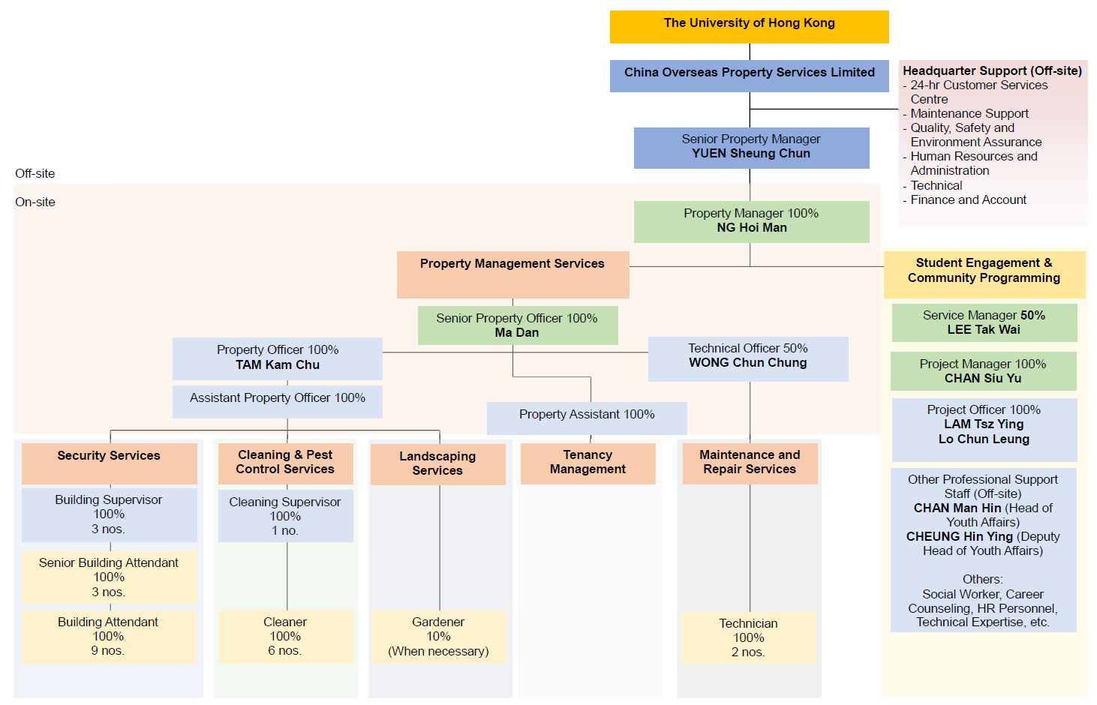

  - CV of Property Management Services Provider
THE KEY PERSON FOR THE PROPERTY MANAGEMENT TEAM

Staff  assigned to this contract  (name) | Key person | Part 1 – Qualification |  | Part 2 – Experience
 |  | Professional Qualifications | Date of award (mm/yy) | Year of Post Qualification Experience in the capacity of the Position in this proposal | Employment Period
 |  |  |  |  | Company | Post | From  (dd/mm/yy) | To  (dd/mm/yy)
Property Management Services Provider
NG Hoi Man | Property Manager  (Key Person) | Professional Diploma in Housing Management  The University of Hong Kong (SPACE) | 2019 | 11  Minimum Requirement for the Position proposed for this proposal:  - A minimum of 2 years’ post-professional qualification experience  - In possession of, at least a Higher Diploma (or equivalent) in any discipline  - In possession of, at least Property Management Practice Licence (Tier 2) from the Property Management Services Authority (PMSA) | China Overseas Property Services Limited | Property Manager I  of Po Tin Estate (exceed HK$40 million per annum) | 2025 | Present
 |  | Property Management Practitioner (Tier 1) Licence | 2023 |  | China Overseas Property Services Limited | Property Manager I  of Po Tin Estate (exceed HK$40 million per annum) | 2025 | 2025
 |  | Member of the Hong Kong Institute of Housing | 2022 |  | China Overseas Property Services Limited | Property Manager II  of Po Tin Estate (exceed HK$40 million per annum) | 2023 | 2025
 |  |  |  |  | China Overseas Property Services Limited | Assistant Property Manager  of Po Tin Estate (exceed HK$40 million per annum) | 2022 | 2023
 |  |  |  |  | China Overseas Property Services Limited | Assistant Property Manager  of Shan King Estate | 2021 | 2022
 |  |  |  |  | Harriman Property Management Limited | Estate Officer | 2020 | 2021
 |  |  |  |  | MTR | Property Officer | 2019 | 2020
 |  |  |  |  | Pioneer Management Limited | Property Service Officer | 2018 | 2019
 |  |  |  |  | Sunbase International Properties Management Limited | Property Service Officer | 2015 | 2018
 |  |  |  |  | Creative Property Services Consultants Limited | Property Officer | 2014 | 2015
Ma Dan | Senior Property Officer | Diploma in Hotel Management  Foshan Polytechnic | 2018 | 7  Minimum Requirement for the Position proposed for this proposal:  - A minimum of 3 years’ post-professional qualification experience, and at least 1 years is at rank of managerial and supervisory level  - In possession of, at least a Higher Diploma (or equivalent) in any discipline;  - In possession of, at least a Property Management Practice Licence (Tier 2) from the Property Management Services Authority (PMSA); | China Overseas Property Services Limited | Property Manager  Of University of Macau N1 Juxian Building (University) | 2023 | Present
 |  | Certificate in Golden Key Butler Service | 2023 |  | China Overseas Property Services Limited | Property Manager  Of University of Macau postgraduate dormitory (University) | 2019 | 2023
 |  | Certified Intermediate Tea Artist |  |  | Home Inn Business Hotel | Lobby Deputy Manager | 2018 | 2019
 |  | Certificate for Red Cross First Aider | 2024
TAM Kam Chu | Property Officer | Professional Diploma in Housing Management  The University of Hong Kong (SPACE) | 2025 | 7  Minimum Requirement for the Position proposed for this proposal:  - A minimum of 2 years’ post-professional qualification experience  - In possession of, at least a Higher Diploma (or equivalent) in any discipline  - In possession of, at least Property Management Practice Licence (Tier 2) from the Property Management Services Authority (PMSA) | China Overseas Property Services Limited | Property Officer  of Po Tin Estate (exceed HK$40 million per annum) | 2025 | Present
 |  | Property Management Practitioner (Tier 2) Licence | 2024 |  | China Merchants Shipping & Enterprises Company Limited | Assistant Property Officer | 2018 | 2025
WONG Chun Chung | Technical Officer | Vocational Certificate for Electrical Installation Technicians  IVE (Haking Wong) for the Vocational Training Council | 2008 | 11  Minimum Requirement for the Position proposed for this proposal:  - A minimum of 3 years’ post-professional qualification experience  - At least have a Diploma or Higher Certificate in Building or Building Studies or equivalent, or above | China Overseas Property Services Limited | Building Services Engineer | 5/2018 | Present
 |  |  |  |  | Harriman Property Management Limited | Building Engineer | 5/2017 | 5/2018
 |  |  |  |  | China Overseas Property Services Limited | Engineer | 9/2016 | 5/2017
 |  | Higher Diploma in Electrical Engineering  IVE (Haking Wong) for the Vocational Training Council | 2013 |  | Hong Yip Service Company Ltd. | Technical Officer | 12/2015 | 5/2017
 |  |  |  |  | VCC Land Limited (V Hotels & Services Apartments | Repair & Maintenance Supervisor | 12/2014 | 9/2015
 |  | Certificate of Registration of Electrical Worker（B0） | 2021 |  | Hong Yip Service Company Ltd. | Technical Officer | 4/2014 | 11/2014
 |  | Construction Industry Safety Training Certificate | 2021 |  | Sino Estates Management Ltd. | Maintenance Supervisor | 10/2012 | 8/2012
 |  |  |  |  | City base Property Management Ltd. | Technician | 4/2011 | 8/2012
 |  |  |  |  | Sino Estates Management Ltd. | Technician | 11/2008 | 4/2011

KEY PERSONS (1) FOR THE PROPERTY MANAGEMENT SERVICES PROVIDER
Name of the key person: NG Hoi Man
Current position: Property Manager

Property Management Practitioner (Tier 1) Licence in Hong Kong under the Property Management Services Authority (PMSA) since 2023
Member of the Hong Kong Institute of Housing in Hong Kong since 2022
12 years’ post-professional qualification experience in property management

#Remark: (1) Similar Nature and Scope; (2) Universities, (3) Conversion, Design and Execution and completion of works at Residential Building, Hotel, Hostel; (4) Property Management at Residential building, Hotel Hostel; (5) other relevant experience
EXPERIENCE IN THE PROPERTY MANAGEMENT PROJECTS
COMPANY NAME | EMPLOYMENT PERIOD |  | POST | DUTIES | PROJECT TITLES | Annual Contract Sum ($M) | Details of experience in project (#Remark)
 | FROM  (dd/mm/yy) | TO  (dd/mm/yy
China Overseas Property Services Limited | 2025 | Present | Property Manager I | 12 years’ post-professional qualification experience in property management  - Act as a communication point with Clients;  - Responsible for the overall management in all aspects at Contract Venues, supervising performance of frontline staff and the services contractors;  - Develop and ensure the smooth execution of various service procedures;  - Handle and respond to emergencies, lead the emergency response team, and report to Clients;  - Review and approve all service data and reports;  - Submit work reports and provide suggestions and measures for service improvement to Clients;  - Ensure all staff adhere to established work procedures and provide necessary work guidelines;  - Inspect and review the work of subordinates and be responsible for their performance evaluation;  - Handle issues at Contract Venues in a timely manner according to the regulations (and other rules), attempting to immediately stop disputes, prevent violations and disruptive behavior, etc., and contact the Clients in serious cases; and  Any other related tasks as instructed by Clients. | Property Services for Po Tin Estate | HK$61.2M | (4)
 | 2025 | 2025 | Property Manager I
 | 2023 | 2025 | Property Manager II
 | 2022 | 2023 | Assistant Property Manager
 | 2021 | 2022 | Assistant Property Manager |  | Property Services for Shan King Estate | /
Harriman Property Management Limited | 2020 | 2021 | Estate Officer |  | Property Services for NEO | /
MTR | 2019 | 2020 | Property Officer |  | Property Services for Ocean Pride | /
Pioneer Management Limited | 2018 | 2019 | Property Service Officer |  | Property Services for Upper Wong Tai Sin Estate | /
Sunbase International Properties Management Limited | 2015 | 2018 | Property Service Officer |  | Property Services for Upper Wong Tai Sin Estate | /
Creative Property Services Consultants Ltd | 2014 | 2015 | Property Officer |  | Property Services for Sau Mau Ping Estate | /

NAME | PROJECT DESCRIPTION | Past Performance Record
NG Hoi Man | Po Tin Estate - China Overseas Property Services Limited | 中電 物業管理公司嘉許計劃2025 – 積極慳電大獎
 |  | Hong Kong Volunteer Award 2024 - Caring Estate
 |  | Commendation Scheme on Source Separation of Domestic Waste – Certificate of Merit
 |  | Hong Kong Volunteer Award 2023 - Caring Estate
 |  | Hong Kong Awards for Environmental Excellence 2022
 | MTR | Site handover from the Developer
 | Harriman Property Management Limited | HKGBC BEAM PLUS (PLATINUM)

